**Generation of modified repressilator network(s) to model effect of light on Circadian rhythm**Lakshya Chauhan (UG 3rd Year)

## Abstract

24-hour circadian rhythms have been observed in most organisms, and a few gene circuits have been identified for the same. One of them is a repressilator at the core of mammalian circadian rhythm, which executes 24-hour oscillations with optimal input from environmental light conditions. However, a variation in physiological responses such as GFR, body temperature, etc have been observed between daylight and nigh-time conditions. This study aims to develop a basic repressilator *in silico* under the control of a singular signal, which when varied would induce changes in either amplitude or frequency of a protein in the repressilator circuit. My hypothesis is that such a system might also exist in circadian rhythms, inducing physiological changes based on signal levels.

## Diagram Description automatically generatedIntroduction

Data based statistical approaches have led to the discovery of a repressilator system comprising of *cry1*, *per2* and ­*rev-erb-α* at the core of the Mammalian Circadian Rhythm (MCR)[1]. *In silico* modelling of repressilator networks have shown steady oscillations under a wide range of parameters, with a wide range of models. It should be noted that 2 nodes forming the MCR-GRN are directly affected by light conditions. Recently, a repressilator network called CRISPRlator [2]was constructed, and was shown to have stable oscillations with 17-18 hour periodicity, albeit noisy. This was a modular and an improvement on the first synthetic circuit ever made, the repressilator [3].

Figure : Gene Regulatory Network (GRN) from statistical methods, highlighting strengths of interactions.[1]

Other studies have shown that there are fluctuations in physiological activities like plasma melatonin levels, core body temperature, etc are also modulated based on the time of the day in normal subjects with stable circadian rhythms [4]. Given the correlation between levels of such physiological responses and timepoint during the day, there must be a change in some gene expression patterns that would lead to alteration of downstream processes. Such a change can happen due to multiple reasons, however, a change in the amplitude or frequency of oscillations seems a good starting point. This hypothesis would be supported by studies that have show a change in the circadian rhythm frequency for people suffering from blindness/subjected to abnormal lighting conditions (such as 6-months winter at the poles) [5],[6]. All these conclusions place strong confidence in the hypothesis.

## Results

### Simulations and modelling of repressilator

Following initial studies by Elowitz, similar ODEs were constructed to model the repressilator. It should be noted that these ODEs are highly simple, and while this solves the issue of complexity, large parameter space and simulation times, it might not be representative of actual activity at all. The ODEs utilized are as follows:

$$\frac{dm_{i}}{dt}= -m_{i}+\frac{α}{1+p_{j}^{n} } , \frac{dp_{i}}{dt}= -β(p_{i}-m_{i})$$

Where $m_{i}$ is the mRNA levels of protein $i$, under repression from protein $j$ (as indicated by the hill function). It should be noted that $i,j$ move cyclically across the three nodes, represented by A, B and C. Simulating this network for different alpha and beta values yields a multitude of oscillations, depicted in Figure 2 (top).

As can be observed, steady oscillations with clearly varying frequencies can be observed. Since alpha is the main parameter being changed here, this is a good direction for the hypothesis. Comparing Figure2 (top left) and (top centre), we can clearly see the difference in frequency. The amplitudes are also affected, most probably due to the asymmetric parameters in the first scenario. Hence a scheme evolving a basic repressilator by adding more genes or signals *in silico* could give us an altered repressilator that can be someday constructed using CRISPR-a and CRISPR-i[7].

Figure 2: (top) protein expressions of repressilator under various parameters. (bottom) Corresponding Fourier transforms.

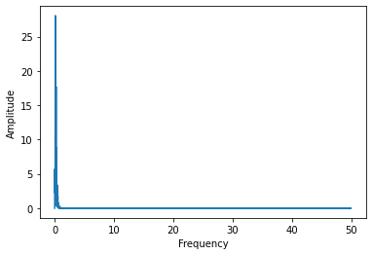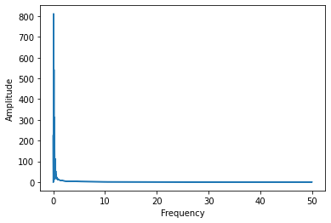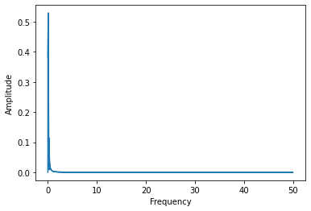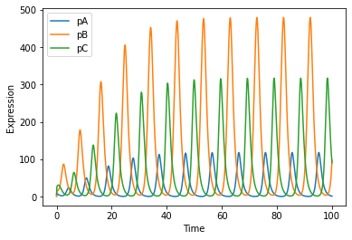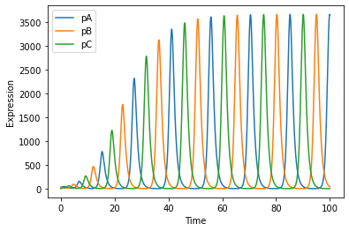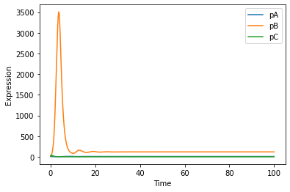

### Measuring frequency and amplitude of basic repressilator

At the first go, the most obvious approach to calculating periodicity of any waveform would be the Fourier transform. Hence, Fourier transform was performed for repressilator under various conditions (Figure2 (bottom)), and the peak magnitude frequency was selected as the base frequency. Since the ODE are not sinusoidal in nature, we can expect that the waveforms of protein and mRNA expressions would also not be sinusoidal. As expected, the approach outlines above resulted in large errors, with deviations as large as 30 percent observed for various parameter sets. Hence a different approach was needed.

Here, the peak values were taken, and the regions above 95 percent peak height were isolated. Next, a sliding algorithm was applied on the isolated peaks to find the peak point (due to computational limits, only max cannot be considered). Then the average times between found peaks was taken to find the periodicity. The suggested method worked and was benchmarked to be used for finding frequencies of any waveforms henceforth.

### Checking variation of frequency and amplitude with change in production levels

Before going ahead with checking all combinations of single signal affected, a basic test regarding the validity of hypothesis could be seen by changing the production value of a protein and looking for variations in amplitude and frequency. By varying $α_{A}$ over a large range, the following plots were obtained

It was observed that oscillations were upheald for a large range (amplitude > 1000), and all three proteins were synchronised in terms of their freqeuncies. However, the amplitudes of protein B were not in sync with that of the other two, and this could be blamed on to

Figure : (left) Amplitude of rep proteins vs production values of A; (right) time periods of rep proteins vs production values of A

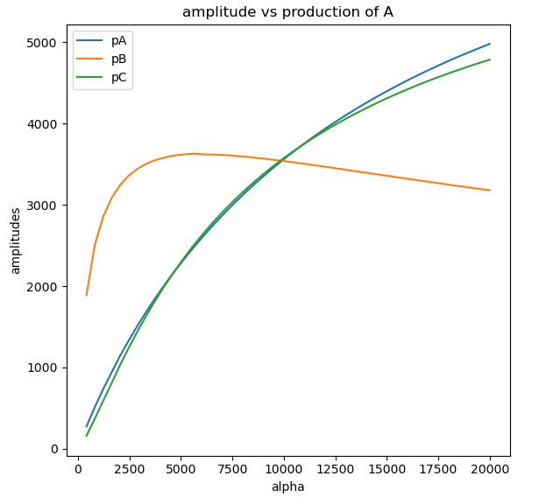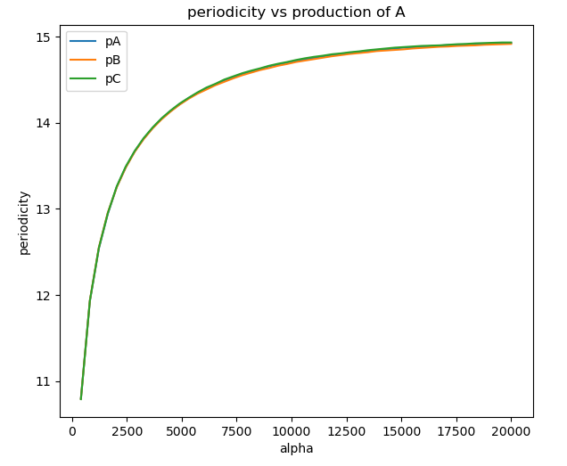

## References

1. Pett, J. Patrick, et al. "Feedback loops of the mammalian circadian clock constitute repressilator." PLoS computational biology 12.12 (2016): e1005266.
2. Santos-Moreno, Javier, et al. "Multistable and dynamic CRISPRi-based synthetic circuits." *Nature communications* 11.1 (2020): 1-8.
3. Elowitz, Michael B., and Stanislas Leibler. "A synthetic oscillatory network of transcriptional regulators." *Nature* 403.6767 (2000): 335-338.
4. Duffy, Jeanne F., and Charles A. Czeisler. "Effect of light on human circadian  
   physiology." Sleep medicine clinics 4.2 (2009): 165-177.
5. Zheng, Xiangzhong, and Amita Sehgal. "Speed control: cogs and gears that drive the circadian clock." *Trends in neurosciences* 35.9 (2012): 574-585.
6. Klein, Torsten, et al. "Circadian Sleep Regulation in the Absence of Light Perception: Chronic Non-24-Hour Circadian Rhythm Sleep Disorder in a Blind Man With a Regular 24-Hour Sleep—Wake Schedule." *Sleep* 16.4 (1993): 333-343.
7. Didovyk, Andriy, et al. "Transcriptional regulation with CRISPR-Cas9: principles, advances, and applications." *Current opinion in biotechnology* 40 (2016): 177-184.